DEVELOP SIMPLE GAME IN VUE

LU1: SETUP ENVIRONMENT
CLI: A command-line interface (CLI) is a text-based user interface (UI) used to run programs, manage computer files, and interact with the computer.
IDE: An integrated development environment is a software application that provides comprehensive facilities to computer programmers for software development.
Frontend: The front end of a software program or website is everything the user interacts with. From a user standpoint, the front end is synonymous with the user interface. From a developer standpoint, it is the interface design and the programming that makes the interface function.
Backend: The back end consists of servers and databases. Servers control how users access files and databases, as well as organize and structure collections of data. For example, when you log into a website, you enter your username, email, and password.
A single-page application (SPA): is a website design approach where each new page's content is served not from loading new HTML pages but generated dynamically through JavaScript's ability to manipulate the DOM elements on the existing page itself.
Node.js is an open-source, cross-platform, JavaScript runtime environment that executes JavaScript code outside of a browser. Node.js lets developers use JavaScript to write command line tools and for server-side scripting —running scripts server-side to produce dynamic web page content before the page is sent to the user's web browser.

NPM: (Node Package Manager) systems from when npm first was created as a package manager for Node.js.
All npm packages are defined in files called package.json. The content of package.json must be written in JSON.
Dependencies are any task, occurrence, or condition: That depends on the completion of a former
task Or, on which a successor task is dependent
What are the different types of dependencies in Node.js?
Node Package Manager: is a package manager for the Node JavaScript platform. It consists of an npm registry that enables Open-Source developers to publish and share their code. You might need to install a few packages to streamline your project. Packages contain code written by other developers. Our root project has a package.json file that keeps track of all the packages we’ve installed. This file contains information about the project and defines the attributes that npm uses for installing dependencies, running scripts, and identifying the entry point for the package.

The different types of dependencies are:
- Production Dependencies
- Development Dependencies
- Peer Dependencies
- Optional Dependencies
- Bundled Dependencies
Create Package json file: Run the following command from the root directory of the project to create the package.json file.
npm init
Note: Npm init prompts you for information about your project such as package name, version, test command, git repository, keywords, author and license.
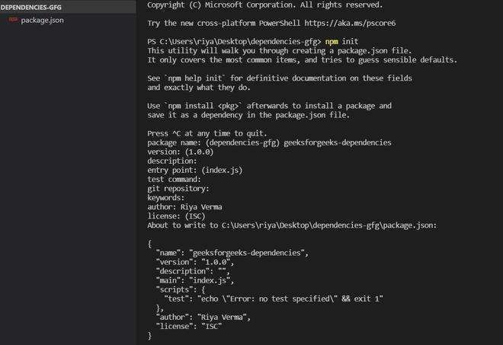
Creating a package.json file

Adding Package: Following is the syntax to install the package: npm install <package_name>
Example: Run the following command to install express package:
npm install express
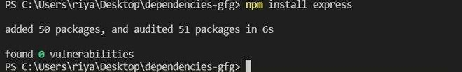
Installing Express (Express is a node.js framework)

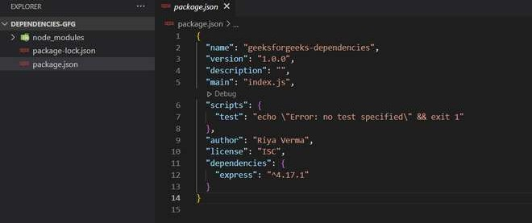
Output: After installing the package, our package.json file will look like this.
package.json file
Besides the details you entered about the project, you’ll notice the dependencies section. Dependencies are libraries on which the project relies to function effectively.
- PRODUCTION DEPENDENCIES:
Production dependencies are fundamental dependencies that are required to complete the project. Package.json specifies these dependencies under the key “dependencies”. These are the packages used in the project code. If a package doesn’t already exist in the node_modules directory, then it is automatically added. These are the libraries you need when you run your code. For example, To run a react project, you need react-dom. In our production dependencies, you will find the express package we just installed.
- DEVELOPMENT DEPENDENCIES:
As a developer, you may want to install dependencies to build and test your website. The packages required by a developer during development are called devDependencies. Dependencies that you might need at some point in the development process, but not during execution. They are not included in the production version and will not be downloaded to end user’s browser caches. For example, Nodemon, lodash, Babel etc.
Note: Nodemon helps developers create node.js applications by automatically restarting the node application when a file change is detected in the directory.
Adding dev dependency: By using the following command, let’s add nodemon as a dev dependency:
Syntax: npm install <package_name> --save-dev Example: npm install nodemon --save-dev

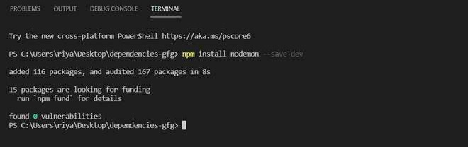
Installing Nodemon

Output: Let’s look at our package.json file. The package.json file now includes the nodemon package under dev dependencies.
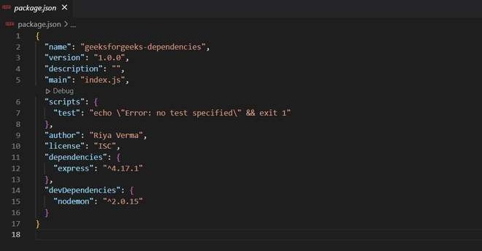
package.json file after installing nodemon

As you install a package, npm will automatically install the package’s dependencies and dev dependencies. In addition to these dependencies, we also have peer dependencies.
- PEER DEPENDENCIES:
The only time you would encounter peer dependencies is if you were publishing your own package ie, when you develop a code that will be used by other programs. Libraries use peerDependencies to tell developers which other libraries with the exact version they will need to install in their own websites to use your library. Therefore, peer dependencies also express compatibility.

The peerDependencies ensure that the code is compatible with the version of the package installed. peerDependencies are not automatically installed. You need to manually modify your package.json file in order to add a Peer Dependency. For packages like react, this will ensure that there is a single copy of react-dom which is also used by the person installing the package. Even though the package relies on React, it has no direct dependency. Things such as React and React-dom are required, but not installed.
- OPTIONAL DEPENDENCIES:
As the name implies, optional dependencies are those that won’t cause a failure during the installation of the dependencies for an application or project because npm will ignore them if they fail. Regardless of whether these dependencies are present or not, the application will still run just fine. Adding a dependency as optional can speed up the installation process for Node projects. However, not all dependencies can really be optional.
Adding dependency as optional: We can use the following command to make a dependency optional: npm i package_name --save-optional
Example: For instance, we will install the chalk package as an optional dependency. Using the chalk library, we can easily enforce colors and styles on our terminal output. npm i chalk --save-optional
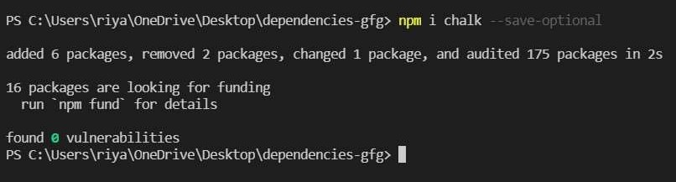
Installing chalk

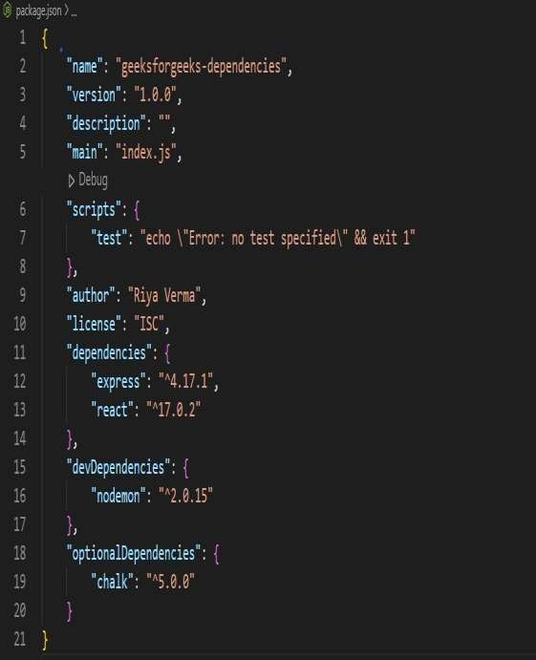
You will find your package under the “optionalDependencies” key in package.json.

package under optionalDependencies Chalk

- BUNDLED DEPENDENCIES:
When publishing the package, these dependencies are bundled with it. NPM packages are preserved locally or can be downloaded from a single file. For example, express, request packages can be bundled.
BundledDependencies are listed as an array, without versions. Bundled Dependencies have the same functionality as normal dependencies. When normal dependencies are insufficient, bundled dependencies can be useful. They are rarely used.

environment : gives you support for file access, network access, database access etc. You would be starting your program like this: $ node app.js In the browser environment, you have access to window, document, XMLHttpRequest etc., which are inbuilt to that environment.
Development is a process that creates growth, progress, positive change or the addition of physical, economic, environmental, social and demographic components.
Testing is finding out how well something works. Find software errors and verify that an application or system is fit for users.

How does software testing work?
Software testing is the process of evaluating and verifying that a software product or application does what it is supposed to do.
Production is the method of turning raw materials or inputs into finished goods or products in a manufacturing process. In other words, it means the creation of something from basic inputs.
INTRODUCTION TO VUE FRAMEWORK
Vue is a JavaScript framework for building user interfaces. Its core part is focused mainly on the view layer and it is very easy to understand. The version of Vue that we are going to use in this tutorial is 2.0.
As Vue is basically built for frontend development, we are going to deal with lot of HTML, JavaScript and CSS files in the upcoming chapters. To understand the details, let us start with a simple example.
In this example, we are going to use the development verison of vuejs. Example
<html>
<head>
<title>VueJs Introduction</title>
<script type = "text/javascript" src = "js/vue.js"></script>
</head>
<body>
<div id = "intro" style = "text-align:center;">
<h1>{{ message }}</h1>
</div>
<script type = "text/javascript"> var vue_det = new Vue({ el: '#intro', data: {
message: 'My first VueJS Task'
}
});
</script>
</body>
</html>

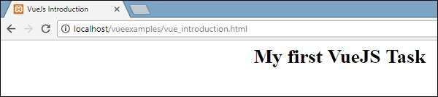
Output

This is the first app we have created using VueJS. As seen in the above code, we have included vue.js at the start of the .html file.
<script type = "text/javascript" src = "js/vue.js"></script>
There is a div which is added in the body that prints “My first VueJS Task” in the browser.
<div id = "intro" style = "text-align:center;">
<h1>{{ message }}</h1>
</div>
We have also added a message in a interpolation, i.e. {{}}. This interacts with VueJS and prints the data in the browser. To get the value of the message in the
DOM, we are creating an instance of vuejs as follows −
var vue_det = new Vue({ el: '#intro',
data: {
message: 'My first VueJS Task'
}
})
In the above code snippet, we are calling Vue instance, which takes the id of the DOM element i.e. e1:’#intro’, it is the id of the div. There is data with the message which is assigned the value ‘My first VueJS Task’. VueJS interacts with DOM and changes the value in the DOM {{message}} with ’My first VueJS Task’.
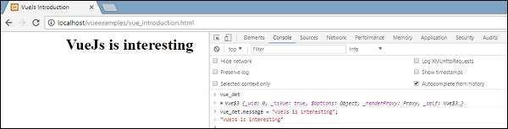
If we happen to change the value of the message in the console, the same will be reflected in the browser. For example −

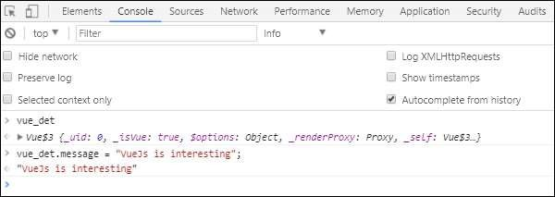
Console Details
In the above console, we have printed the vue_det object, which is an instance of Vue. We are updating the message with “VueJs is interesting” and the same is changed in the browser immediately as seen in the above screenshot.
This is just a basic example showing the linking of VueJS with DOM, and how we can manipulate it. In the next few chapters, we will learn about directives, components, conditional loops, etc.

INSTALLATION OF NODEJS

Node.js can be installed in different ways. This post highlights the most common and convenient ones. Official packages for all the major platforms are available at https://nodejs.dev/download/.
One very convenient way to install Node.js is through a package manager. In this case, every operating system has its own. Other package managers for MacOS, Linux, and Windows are listed in https://nodejs.dev/download/package-manager/
nvm is a popular way to run Node.js. It allows you to easily switch the Node.js version, and install new versions to try and easily rollback if something breaks.
It is also very useful to test your code with old Node.js versions.
See https://github.com/nvm-sh/nvm for more information about this option.

In any case, when Node.js is installed you'll have access to the node executable program in the command line. Verify Installation
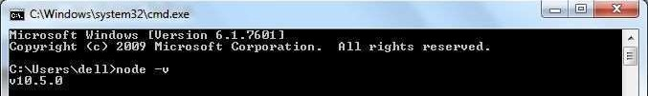
Once you install Node.js on your computer, you can verify it by opening the command prompt and typing node -v. If Node.js is installed successfully then it will display the version of the Node.js installed on your machine, as shown below.
npm-config

Manage the npm configuration files
Select CLI Version:Version 7.24.2 (Legacy Release) Synopsis

npm config set <key>=<value> [<key>=<value> ...] npm config get [<key> [<key> ...]] npm
config delete <key> [<key> ...] npm
config list [--json] npm config edit
npm set <key>=<value> [<key>=<value> ...] npm get [<key> [<key> ...]] alias: c

Note: This command is unaware of workspaces.

Description npm gets its config settings from the command line, environment variables, npmrc files, and in some cases, the package.json file.
See npmrc for more information about the npmrc files.
See config(7) for a more thorough explanation of the mechanisms involved, and a full list of config options available.
The npm config command can be used to update and edit the contents of the user and global npmrc files.

Sub-commands
Config supports the following sub-commands:

set
npm config set key=value [key=value...] npm set key=value [key=value...]
Sets each of the config keys to the value provided. If value is omitted, then it sets it to an empty string.
Note: for backwards compatibility, npm config set key value is supported as an alias for npm config set key=value.

get
npm config get [key ...] npm get [key ...]

Echo the config value(s) to stdout.
If multiple keys are provided, then the values will be prefixed with the key names. If no keys are provided, then this command behaves the same as npm config list.
list

npm config list

Show all the config settings. Use -l to also show defaults. Use --json to show the settings in json format.

delete
npm config delete key [key ...]
Deletes the specified keys from all configuration files. edit

npm config edit
Opens the config file in an editor. Use the --global flag to edit the global config.
Configuration json

- Default: false
- Type: Boolean
Whether or not to output JSON data, rather than the normal output.
- In npm pkg set it enables parsing set values with JSON.parse() before saving them to your package.json. Not supported by all npm commands.

global

- Default: false
- Type: Boolean
Operates in "global" mode, so that packages are installed into the prefix folder instead of the current working directory. See folders for more on the differences in behavior.

- packages are installed into the {prefix}/lib/node_modules folder, instead of the current working directory.
- bin files are linked to {prefix}/bin
- man pages are linked to {prefix}/share/man editor

- Default: The EDITOR or VISUAL environment variables, or 'notepad.exe' on Windows, or 'vim' on Unix systems
- Type: String
The command to run for npm edit and npm config edit.

location

- Default: "user" unless --global is passed, which will also set this value to "global"
- Type: "global", "user", or "project"
When passed to npm config this refers to which config file to use.

long

- Default: false
- Type: Boolean
Show extended information in ls, search, and help-search.
testing js files using nodejs
I try to understand how to test js files. Look, I have a file emotify.js with function: function emotify(string) {
return string + '' + ' :)';
}
and then I created another file - index.js with the content below: var emotify = require('./emotify.js');
console.log(emotify('just testing')); but
console push me an error TypeError: emotify is not a function

When you require a module the result is what the module have exported. In this case you will need to export your function: emotify.js code:
module.exports = function(string) { return string
+ '' + ' :)';
}

Variant 1 emotify.js:
module.exports = function emotify(string) { // Named function, good for call stack at debugging. You are pro, right ? return string + '' + ' :)';
}
test.js:
const emotify = require('./emotify.js'); // const instead of var, cause you are pro :) console.log(emotify('just testing'));

Variant 2 mylib.js: function emotify(string) {

return string + '' + ' :)';
}

function anotherFunc(string) { return string
+ '' + ' :)';
}

module.exports = { emotify, anotherFunc,
};
test.js:
const mylib = require('./mylib.js');

console.log(mylib.emotify('just testing')); console.log(mylib.anotherFunc('just testing'));
Overview of VUE CLI
Vue CLI is a full system for rapid Vue.js development, providing:



Interactive project scaffolding via @vue/cli. A runtime dependency (@vue/cli-service) that is: o Upgradeable;
- Built on top of webpack, with sensible defaults; o
Configurable via in-project config file;
- Extensible via plugins
- A rich collection of official plugins integrating the best tools in the frontend ecosystem.
- A full graphical user interface to create and manage Vue.js projects.

Vue CLI aims to be the standard tooling baseline for the Vue ecosystem. It ensures the various build tools work smoothly together with sensible defaults so you can focus on writing your app instead of spending days wrangling with configurations. At the same time, it still offers the flexibility to tweak the config of each tool without the need for ejecting.

Components of the System

There are several moving parts of Vue CLI - if you look at the source code, you will find that it is a monorepo containing a number of separately published packages. CLI
The CLI (@vue/cli) is a globally installed npm package and provides the vue command in your terminal. It provides the ability to quickly scaffold a new project via vue create. You can also manage your projects using a graphical user interface via vue ui. We will walk through what it can do in the next few sections of the guide. CLI Service

The CLI Service (@vue/cli-service) is a development dependency. It's an npm package installed locally into every project created by @vue/cli.

The CLI Service is built on top of webpack and webpack-dev-server. It contains:

- The core service that loads other CLI Plugins;
- An internal webpack config that is optimized for most apps;
- The vue-cli-service binary inside the project, which comes with the basic serve, build and inspect commands.
If you are familiar with create-react-app, @vue/cli-service is roughly the equivalent of react- scripts, although the feature set is different.
The section on CLI Service covers its detailed usage.
CLI Plugins

CLI Plugins are npm packages that provide optional features to your Vue CLI projects, such as Babel/TypeScript transpilation, ESLint integration, unit testing, and end-to-end testing. It's easy to spot a Vue CLI plugin as their names start with either @vue/cli-plugin- (for built-in plugins) or vue-cliplugin- (for community plugins).
When you run the vue-cli-service binary inside your project, it automatically resolves and loads all CLI Plugins listed in your project's package.json.
Plugins can be included as part of your project creation process or added into the project later. They can also be grouped into reusable presets. We will discuss these in more depth in the Plugins and Presets section.

Installation of VUE CLI with NPM

Node Version Requirement

Vue CLI 4.x requires Node.js version 8.9 or above (v10+ recommended). You can manage multiple versions of Node on the same machine with n, nvm or nvm-windows.

To install the new package, use one of the following commands. You need administrator privileges to execute these unless npm was installed on your system through a Node.js version manager (e.g. n or nvm).
npm install -g @vue/cli # OR yarn global add @vue/cli
After installation, you will have access to the vue binary in your command line. You can verify that it is properly installed by simply running vue, which should present you with a help message listing all available commands.
You can check you have the right version with this command: vue --version Upgrading#

To upgrade the global Vue CLI package, you need to run: npm update -g @vue/cli
# OR
yarn global upgrade --latest @vue/cli
Project Dependencies#

Upgrade commands shown above apply to the global Vue CLI installation. To upgrade one or more @vue/cli related packages (including packages starting with @vue/cli-plugin- or vue- cli-plugin-) inside your project, run vue upgrade inside the project directory:
Usage: upgrade [options] [plugin-name]
(experimental) upgrade vue cli service / plugins Options:
-t, --to <version> Upgrade <plugin-name> to a version that is not latest -f, --from
<version> Skip probing installed plugin, assuming it is upgraded from the designated version
-r, --registry <url> Use specified npm registry when installing dependencies
--all Upgrade all plugins
--next Also check for alpha / beta / rc versions when upgrading -h, --help output usage information

Creating a Project vue
create#
To create a new project, run: vue create hello-world

WARNING
If you are on Windows using Git Bash with minTTY, the interactive prompts will not work. You must launch the command as winpty vue.cmd create helloworld. If you however want to still use the vue create hello-world syntax, you can alias the command by adding the following line to
your ~/.bashrc file. alias vue='winpty vue.cmd' You will need to restart your Git Bash terminal session to pull in the updated bashrc file.

You will be prompted to pick a preset. You can either choose the default preset which comes
with a basic Babel + ESLint setup, or select "Manually select features" to pick the features you need.

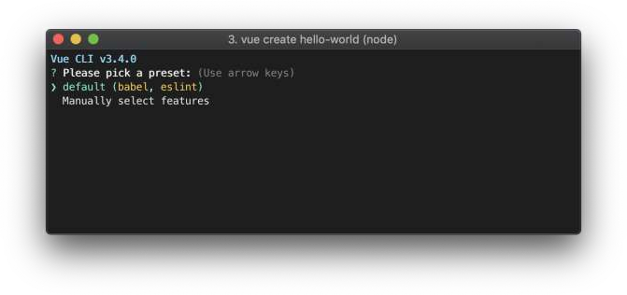

The default setup is great for quickly prototyping a new project, while the manual setup provides more options that are likely needed for more production-oriented projects.
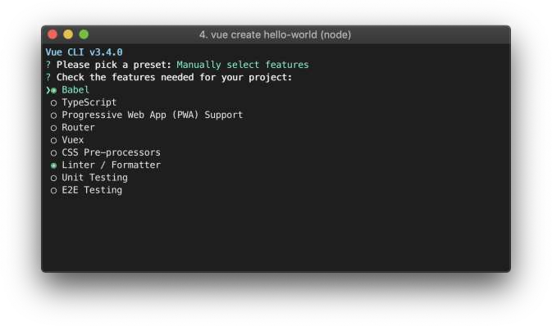
If you chose to manually select features, at the end of the prompts you also have the option to save your selections as a preset so that you can reuse it in the future. We will discuss presets and plugins in the next section.

~/.vuerc

Saved presets will be stored in a JSON file named .vuerc in your user home directory. If you wish to modify saved presets / options, you can do so by editing this file.
During the project creation process, you may also be prompted to select a preferred package
manager, or use the Taobao npm registry mirror for faster dependency installation. Your choices will also be saved in ~/.vuerc.

The vue create command has a number of options and you can explore them all by running: vue create --help
Usage: create [options] <app-name>

create a new project powered by vue-cli-service

Options:

-p, --preset <presetName> Skip prompts and use saved or remote preset
-d, --default Skip prompts and use default preset
-i, --inlinePreset <json> Skip prompts and use inline JSON string as preset
-m, --packageManager <command> Use specified npm client when installing dependencies
-r, --registry <url> Use specified npm registry when installing dependencies
-g, --git [message|false] Force / skip git initialization, optionally specify initial commit message
-n, --no-git Skip git initialization
-f, --force Overwrite target directory if it exists
--merge Merge target directory if it exists
-c, --clone Use git clone when fetching remote preset
-x, --proxy Use specified proxy when creating project
-b, --bare Scaffold project without beginner instructions
--skipGetStarted Skip displaying "Get started" instructions
-h, --help Output usage information

Using the GUI
You can also create and manage projects using a graphical interface with the vue ui command: vue ui
The above command will open a browser window with a GUI that guides you through the project creation process.

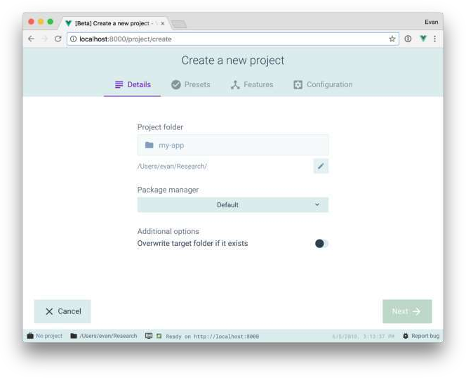

Pulling 2.x Templates (Legacy)#

Vue CLI >= 3 uses the same vue binary, so it overwrites Vue CLI 2 (vue-cli). If you still need the legacy vue init functionality, you can install a global bridge:
npm install -g @vue/cli-init
# vue init now works exactly the same as vue-cli@2.x vue init webpack my-project.

Introduction nodeJS
In this article, I am going to introduce NodeJS with Node Package Module (NPM), step- by-step basic implementation and explanation. This article covers the following areas of NodeJS.

- Introduction of NodeJS
- Installation of NodeJS and NPM

- Node Package Module (NPM)
- Package.json
- Basic Example

NodeJS
NodeJS is an open-source, cross-platform runtime environment for developing server-side web applications. NodeJS also has an event-driven architecture capable of asynchronous I/O. NodeJS uses an event-driven, non-blocking I/O model that makes it lightweight and efficient.

Installation of NodeJS and NPM
Installation of NodeJS and NPM is straightforward using the installer package available at NodeJS official web site.

- Download the installer from NodeJS WebSite.
- Run the installer.
- Follow the installer steps, agree the license agreement and click the next button.
- Restart your system/machine.
Now, test NodeJS by printing its version using the following command in Command Prompt:
bash
1> node -v and test npm by printing its version using command
1> npm -v
bash
Simple way to test nodeJS work in your system is to create a javascript file which print a message.
Lets create test.js file
1/*test.js file*/
2console.log("Node is working");
js
Run the test.js file using Node command > node test.js in command prompt.

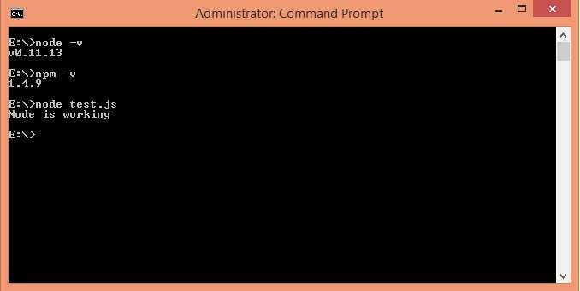
You are done with installation.

Node Package Module
NPM is the package module which helps javascript developers load dependencies effectively. To load dependencies we just have to run a command in command prompt:
1> npm install bash
This command is finding a json file named as package.json in root directory to install all dependencies defined in the file.

Package.json
Package.json looks like:
1{
- "name": "ApplicationName",
- "version": "0.0.1",

- "description": "Application Description",
- "main": "server.js",
- "scripts": {
- "start": "node server.js"
8 },
- "repository": {
- "type": "git",
- "url": "https://github.com/npm/npm.git"
12 },
13 "dependencies": {
14 "express": "~3.0.1",
- "sequelize": "latest",
- "q": "latest",
- "tedious": "latest",
- "angular": "latest",
- "angular-ui-router": "~0.2.11",
- "path": "latest",
- "dat-gui": "latest"
22 }
23}
json
The most important things in your package.json are name and version. Those are actually required, and your package won't install without them. The name and version together form an identifier that is assumed to be completely unique. Changes to the package should come along with changes to the version.

Repository
1{
- "repository": {
- "type": "git",
- "url": "https://github.com/npm/npm.git"
- }
6}
json

Specify the place where your code lives. Through this repository, developers can reach out and contribute to your application. If the git repository is not GitHub, then the npm docs command will be able to find you.

Scripts
1{
- "scripts": {
- "start": "node server.js"
4 }
5}
json
NPM provide many useful Scripts like npm install, npm start, npm stop etc. Some default script values are based on package contents.
1"start": "node server.js"
json
If there is a server.js file in the root of your package, then npm will default the start command to node server.js.
Dependencies
1{
2"dependencies": {
3 "express": "~3.0.1",
- "sequelize":"latest",
- "q":"latest",
- "tedious":"latest",
- "angular":"latest",
- "angular-ui-router": "~0.2.11",
- "path":"latest",
- "dat-gui":"latest"
11 }
12}

json
Dependencies are specified in a simple object that maps a package name to a version range. Version Name must be Version exactly.
If you want to install the latest version of a file, you just have to put latest in place of the version name.

Tilde(~) is used to tell "Approximately equivalent to version".

Basic Example
Create a server.js javascript file with following code
1/*server.js*/ 2
3const http = require('http'); 4
5const hostname = '127.0.0.1'; 6const port = 3000;
7
8const server = http.createServer(function(req, res) {
9 res.statusCode = 200;
10 res.setHeader('Content-Type', 'text/plain');
11 res.end('Hello World\n');
12});
13
14server.listen(port, hostname, function() {
15 console.log('Server running at http://'+ hostname + ':' + port + '/'); 16});
js
As we need http to create an http server we use require('http') and pass it to a
variable named http
1var http = require('http');

js
We also need to defined hostname and port number, here we use localHost i.e 127.0.0.1 and port number 3000 and assign this to the variables hostname and port, respectively.
1var hostname = '127.0.0.1'; 2var port = 3000;
js
Next we create the http server using the createServer method.

1var server = http.createServer(function(req, res){
- res.statusCode = 200;
- res.setHeader('Content-Type', 'text/plain');
- res.end('Hello World\n');
5});
js
This created the server as well as a response having statusCode: 200, ContentType header of plain text and and ends with the string Hello World. This is the response that the server can send to browser.
the function has two parameters req and res which is the request from and response to the server, respectively.
In our example we are creating responses.
We created the server, now we have to assign it a hostname and port number.
1server.listen(port, hostname, function() {
2 console.log('Server running at http://'+ hostname + ':' + port + '/');
3});

js
Here, the server listens to localhost on port 3000 and prints "Server running at http://127.0.0.1:3000/" in command prompt. Now Run server.js file un node using command
1> node server
bash
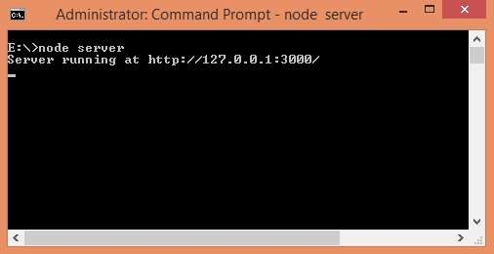
Open a browser and enter url http://127.0.0.1:3000/. The browser will display Hello World message on the screen.

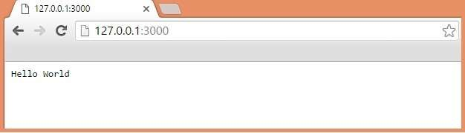

STRUCTURE A LARGE SCALE VUE.JS APPLICATION
Introduction:
As an honest framework, vue.js features a very small learning curve and is straightforward to configure.
When starting a brand new application, the common challenge for an architect or developer are:
- How to structure the appliance as modular, flexible, and scalable.
- How to handle HTTP calls.
- How to do management.
- How to add exception handling.
- How to add logging.
What is the straightforward path to structure a Vue.js application so that it scales and remains maintainable and extendable the more applications grow? This is a problem that I have heard on numerous occasions in which I feel one answer thereto question lies within the principle of predictability. When the application involves creating a scalable project you would like everything about it to be as predictable as possible.
What exactly do I mean by predictability? At its simplest, it’s the power to intuitively go from a feature request or bug report back to the thing within the codebase where said tasks are often addressed. Furthermore, it is the ability to quickly know what tools you’ve got access to at that location within the codebase to finish the task at hand.
I think it’s worth noting here that, while predictability is feasible, no project will ever be 100% predictable. Every project, new or existing will have a minimum of a small learning curve. Also, know that predictability doesn’t suggest that the codebase or application is quickly understood as an entire. Many largescale applications are just too complex for this to be possible and they’ll take time to know in their entirety. Thus, predictability isn’t about seeing the whole finished puzzle but more about knowing the shape of a specific piece and having the power to quickly see where it fits. The character of an honest codebase lends itself to being understandable a bit at a time and should not require its developers to ever need to believe the whole thing at once.

So how can we accomplish predictability during a codebase? The answer: standards, plain and simple. Maybe that’s not the solution you are looking for but it’s true. The best thanks to making anything predictable is to follow a group of standards. For example, I can predict with almost 100% certainty that the new full-size sheets that I bought just today will fit my bed albeit I’ve never dressed it with those sheets before. Why? Because of the quality sizing system for bed sheets.
The standard file structure at the beginning:

The best thanks to starting with Vue.js is to use Vue CLI Configure the project.
Installation requirements: Vue cli 4.x require Node.js version 8.9 or above (v10+ recommended)
$ npm install -g @vue/cli
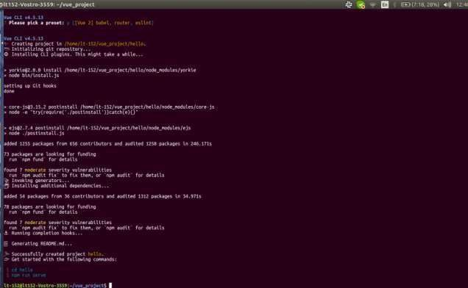
$ vue create hello
The directory structure of the first Vue project:

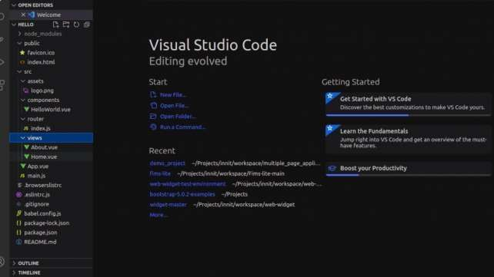
├── dist
├── config ├── public
├── node_modules
├── src
│ ├── App.vue
│ ├── assets
│ │ └── logo.png
│ ├── components
│ │ └── HelloWorld.vue
│ ├── views
│ │ └── About.vue
│ │ └── Home.vue
│ ├── main.js
│ └── router
│ └── index.js

Some important points of the director are the following:
- Assets directory: The assets directory contains uncompiled assets such as Less, Sass, or JavaScript.
- Components directory: The components directory contains all the Components.
- Mixins directory: The mixins directory contains reusable mixins for reusable components and considers components.
- Router directory: The router directory contains all the routes of the application.

- Store directory: The store directory contains all Vuex Store files data and modules.
- Views directory: It contains application views and routes.
Component Recommendation Rules:
Now check the component catalog. The Vue style guide provides us with more tips to make our file structure more predictable. Among other things, the planning guide encourages the next when it involves defining components:
  - When possible each component should be defined in its dedicated file.
  - Single file components should be named in the PascalCase.
  - Base components should start with the same prefix, You can consider base components as your app-wide reusable components sort of a button or a modal
  - The component name should always consist of multiple words to avoid conflicts with existing or future HTML elements. Don’t create form or button components.
  - The single instance components should begin with the prefix o For example, website header or footer o This groups them together and declares them as single-use.
  - Tightly coupled child components should be prefixed with their parent component’s name.
- For instance a TodoListItem during a TodoList. o This groups them together and declares them to be related.

Component names should begin with the foremost top-level (usually general) words and end with the foremost specific
- Such as SearchWidgetInput, SearchWidgetResultsList, SearchWidget.
- This groups related components together within the file structure
Hold tight if these don’t completely add up, there is a picture coming during a moment that can help. Besides these, the entire style guide has several other standards which can help your project be more predictable to a communitywide audience of developers.
Some Recommended Personal/Team-Wide Standards for Predictability: While there are some great standards set in the Vue.js community at large by official sources, there are other patterns not so widely adopted that, will be helpful and made into standards for you or your team’s projects. These standards are necessary because community-wide standards are not 100% complete, but be careful and be strict when it involves how team standards are decided upon and maintained. Many times, if you are not careful, this will become a hiding place for changing rules. That said, here are a variety of my recommendations for your Vue.js project standards.
A Flat Component Directory:
The naming conventions always help group related components together within the file system. A flat component directory has the next benefits:
  - Quickly and easily go from spotting a component in Vue dev tools to finding the enter the codebase (the filename and thus the component name are the same)

  - Use your IDE’s quick find or file jumping feature to filter files supported their most general attribute right down to the more specific
  - Remove analysis paralysis when it involves deciding the thanks to organizing components into subdirectories.
  - Be able to see all of your components directly during one list
  - Get obviate the redundancy of keywords in filenames AND within the directory (that is that if you’re following the planning guide (and you need to be) and you’re using nested directories) (ie. post/PostList.vue, post/PostFeature.vue, etc)
  - Remove the temptation to use short one-word component names which is simpler to try to do with nested directories (ie. post/List.vue, post/Feature.vue ) and violates the planning guide
  - Eliminate surfing the file structure in and out of directories to hunt out a component
  - Simplify importing components. It will always be import SomeComponent from “@/SomeComponent”.
So what does a flat structure that follows the planning guide look like? Here’s an honest example.
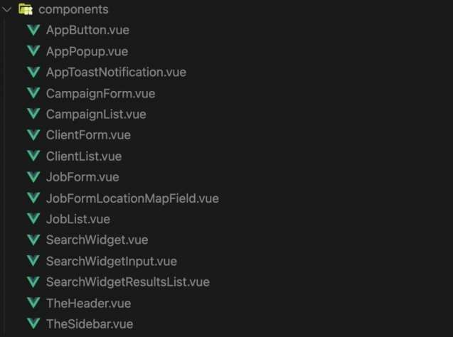
Standardized Route/Page Naming Convention:

Another practice that creates sense may be a standardized way of naming our routes and page components. In your typical CRUD application you’ve got the subsequent different pages for every resource:
- A list of all the resources
- A view of a single resource
- A form to create the resource
- And a form to edit the resource
While a number of these may find yourself being a nested route (like viewing the only resource during a modal overlay from within the list page), they typically find yourself having a fanatical route with a corresponding page.
Since I even have a background within the PHP framework Laravel, when it came to naming routes and predictably defining their paths I intuitively fell back on the standards that Laravel already had in place. Using a users resource as an example, the naming convention prescribed by Laravel and adapted for Vue that I prefer to recommend is as follows:

Path | Route and Component Name | What it Does
/users | UsersIndex | List all the users
/users/create | UsersCreate | Form to create the user
/users/{id} | UsersShow | Display the user’s details
/users/{id}/edit | UsersEdit | Form to edit the user
While tempted to call the route during a more traditional Laravel manner like users. index rather than UsersIndex, I’ve found that using the PascalCase works whilst well and has the extra advantage of matching the component name.
For further consistency and adaptability, you ought to also always reference your routes via their name when using them in router links and when referencing them programmatically.

For example:
<router-link :to=”{name: ‘UsersIndex’}”>Users</router-link> More complete file structure:
Besides the essential file structure that Vue CLI gives you out of the box, I suggest standardizing subsequent for better predictability and management of the file structure.

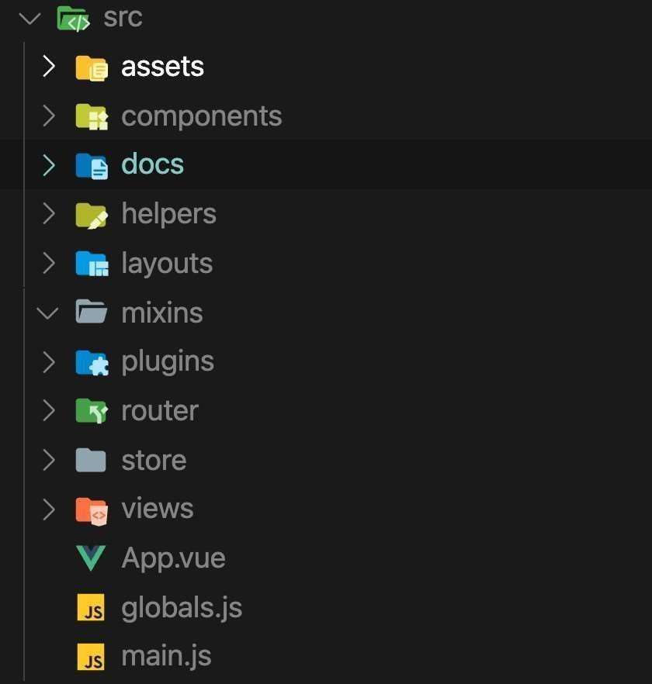
The added directories are documentation, helpers, layouts, mixins, and plugins. You will notice that 4 of the 5 have a flower icon next to them, provided by the VS Code extension material icon theme. That’s because on only one occasion or another, for a couple of frameworks or languages, these directory conventions were common enough to urge their icon within the eyes of the extension developer. That’s no coincidence!
So what are the reasons for these file structure standards?

Docs:
The purpose of this one is obvious but the more important thing is that it’s included and is sitting there staring your team right within the face whenever they open the codebase. If the developer has never successfully uninstalled their IDE, it is more likely to document certain aspects of the project. I’ve also discovered (it was a satisfying surprise) that writing docs first before coding out a Having reusable classes or components often helps me improve the interface or API of such code.
In addition to the documentation directory, I also found a README file, which is a useful file based on any standardized directory. Explain the purpose of the directory and the rules for its content. This is particularly useful for standards that are not applicable to the community.
Helpers:
This is a typical directory in many frameworks for basic input and output functions that can be reused in a project. They are usually easy to test and are usually only used once. I prefer to start with the index.js file, and then as the assistant gets bigger, break it down into more cluster files, such as https.js, cache.js, time.js. Everything during this directory can just be imported and used on-demand and if a function lands up never getting utilized in the smallest amount it’s often easily trees shaken from the assembly bundle.
Layouts:
I got this convention from Nuxt, just like Laravel. Not only define the components of the page but also define the layout components that are reused across multiple pages. As the name suggests, these components define the overall layout, not the content of the page. For example, is it a 1-column or 2column page? Do you have a left sidebar or a right sidebar? Does the layout include standard headers and footers, or is it a completely blank layout, maybe the page content is centered? There are usually only 2 or 3 of these design components, but they are useful abstractions.
Mixins:
This directory is used to organize all your Vue.js mixins. I find it very important to add the word mixin at the beginning of each file name (e.g.
ResourceTableMixin.js) to easily search in the file switcher. Though I even haven’t had the prospect to work on a way bigger scale Vue 3 project yet, I assume this might probably quickly change to a composable directory in preference of extracting reactive data/methods with the Composition API instead of with mixins. Or at least you can add a compound directory to my standard file structure and add it to the mixin directory
Plugins:
The last directory I want to add to all Vue projects is the plugins directory. In the world of packages and libraries, we sometimes do more customization and registration than programming. Although they are called plug-ins, I don’t always use the term in the strictest sense. In other words, it doesn’t get to be a third-party lib registered via the Vue .use() method. This happens often, but sometimes alternative methods are used to fix libraries that use Vue (such as
.component()). For libraries that use 1 or 2 lines of configuration, I will write them in the plugins
/ index.js file.

Conclusion:
While there are some community-wide standards that you simply would have best to not ignore, there’s also the kind of standards you’ll bring back to you or your team to form your codebases more predictable.
As applications grow, so does the problem, which requires better structural management applications. With the help of the above guide, we can Structure a Large Scale Vue.js Application.

LU.2: APPLY VUE FRAMEWORK
Vue
A Guide to Understanding Vue Lifecycle Hooks
Like other frameworks, Vue has a number of lifecycle hooks which allow us to attach code to specific events that occur while a Vue application is being created or used - for example, when the component loads, when a component is added to the DOM, or when something is deleted.
Vue has a lot of lifecycle hooks, and what can be confusing is what each one means or does. In this guide, we’ll be covering what each lifecycle hook does, and how to use them.
Prerequisites

